ASSIGNMENT=MODULE 3 (TESTING ON LIVE APPLICATION)

1. **What is RDBMS?**

* RDBMS stand for Relational Database Management System.
* RDBMS is the basis for SQL, and for all modern database system like MS SQL Server, IBM, DB2, Oracle, MySQL, and Microsoft Access.

1. **What is SQL?**

* SQL is Structured Query Language, which is a domain-specific language used in programming and designed for managing data held in a relational database management system.
* SQL is east to learn.
* SQL is written in the form of queries.

1. **Write SQL Commands?**

* SQL Commands: DDL-Data definition language

DML-Data manipulation language

DCL-Data control language

DQL-Data query language

1. **What is join?**

* A join clause is used to combine rows from two or more table, based on a related column between them.

1. **Write types of joins?**

* There are four types of SQL joins;

1. **Inner join:** returns records that have matching values in both tables.



1. **Left join:** returns all records from the left table, and the matched records from the right table.

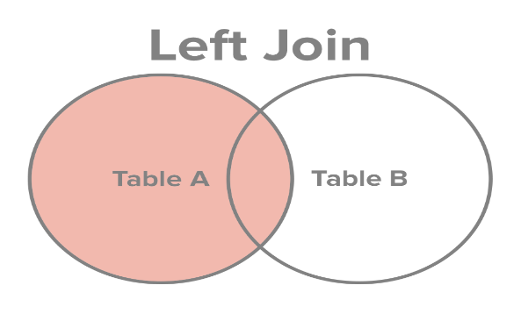

[This Photo](https://tellyouwhat.cn/p/spark2.x-dataframe-join-explained/) by Unknown Author is licensed under [CC BY](https://creativecommons.org/licenses/by/3.0/)

1. **Right join:** returns all records from the right table, and the matched records from the left side.



1. **Full join:** returns all records when there is a match in either left or right table.



1. **How Many Constraints and describes it-self?**

* **Primary key:** unique + not null
* **Foreign key:** its depends on primary table
* **Unique key:** only unique value: blank allow
* **Check:** condition you should apply
* **Not null:** no to be blank
* **Default:** fixed value
* **Index:** when you searching some record at that time apply indexing

1. **Difference between RDBMS and DBMS?**

|  |  |
| --- | --- |
| **RDBMS** | **DBMS** |
| * RDBMS stands for “Relational Database Management System”. | * DBMS stands for “Database Management System”. |
| * RDBMS stores the data in the form of table. | * DBMS technology stores the data in the form of files. |
| * RDBMS provides support for multiple users at a time. | * DBMS provides support only for a single user at a time. |

1. **What is API testing?**

* API testing involves sending requests to the server, analyzing responses, and verifying whether they are correct or not.
* API stand for application programming interface.
* API testing is a vital process that enables evaluating and validating the functionality, reliability, performance and security of application programming interfaces.

1. **Types of API testing?**

* There are mainly 3 types of API testing:

1. **Open APIs:** It has also not given any restriction to use them. So, they are also known as Public APIs.
2. **Partner APIs:** Specific rights or licenses to access this type of API because they are not available to the public.
3. **Internal APIs:** Internal or private, these APIs are developed by companies to use in their internal systems, it helps you to enhance the productivity of your teams.
4. **What is Responsive testing?**

* A responsive web design involves creating a flexible web page that is accessible from any device, starting from a mobile phone to a tablet. Furthermore, a responsive web design improves users’ browsing experience.
* The challenges involved in testing a responsive website:

1. How website testing differs from a mobile device to a computer
2. Rules and guidelines to be followed during responsive design testing and lastly
3. Various tools available to perform responsive testing
4. **Which types of tools are available for Responsive testing?**

* There are five tools available for responsive testing: (1) LT Browser

(2) Lembda Testing

(3) Google Resizer

(4) I am responsive

(5) Pixel tuner

1. **What is the full form of .ipa and .apk?**

* Full form of the .apk is an Android Application Package.
* Full form of the .ipa is a Iphone Application.

1. **How to create step for to open the developer option mode ON?**

* Step 2: scroll down to build number
* Step 3: tap build number seven times. After the first few taps, you should see the steps counting down until you unlock the developer options. You may also have to tap in your PIN for verification.
* Step 4: once developer options are activated, you will see a message that reads, you are now a developer.
* Step 5: go back to the settings pane and head to system, where you will now find developer options entry.

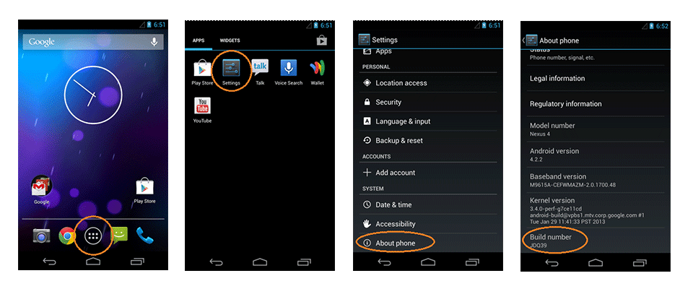

**Step 1 Step 2 Step 3 Step 4**